Mother Tongue Other Tongue 2023-24
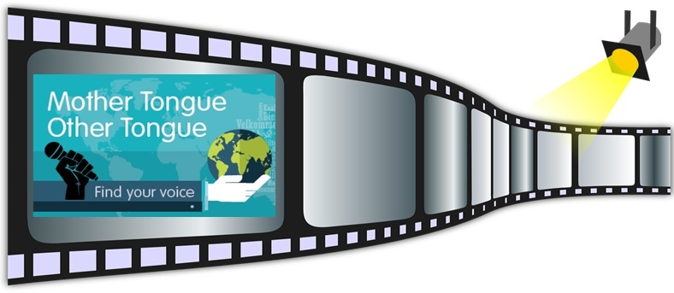
Name | Age Category (delete as appropriate)  P1 – P4 S1 – S3  P5 – P7 S4 – S6
School | Local Authority
In which language is your poem?

Is this your Mother Tongue or Other Tongue?

Your Poem | English Translation
What would you like people to know about your poem? You could say why you wrote it, or what you think is important about it. (Please ensure this section is completed as it forms part of the judging criteria)

